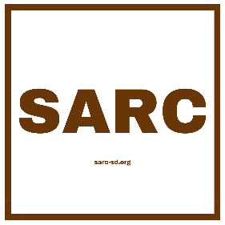

**The Sudanese American Research Center INC**

**75 Arlington Ave, Apt 21 Bloomfield, NJ, USA 07003**

Website: [www.sarc-sd.org](http://www.sarc-sd.org)

E-mail: [info@sarc-sd.org](mailto:info@sarc-sd.org)

**Volunteer Agreement**

**Volunteer Information**

**Full Name:** ____________________________________

**Address:** ______________________________________

**Phone Number:** ________________________________

**Email Address:** ________________________________

**Agreement Terms**

**1. Role and Responsibilities**

As a volunteer at the Sudanese American Research Center, I agree to undertake the following roles and responsibilities:

* To perform my volunteer duties to the best of my ability.
* To follow all guidelines and instructions provided by SARC.
* To maintain confidentiality of all proprietary or privileged information I may be exposed to while serving as a volunteer.
* To communicate any issues or concerns that may arise during my volunteer service to my supervisor as soon as possible.

**2. Time Commitment**

I agree to serve as a volunteer beginning on ________________ [start date] and commit to _______________ hours per week/month until ________________ [end date or ongoing].

**3. Volunteering Conditions**

I understand that my volunteer position at the Sudanese American Research Center (SARC) is unpaid and voluntary, and I am not entitled to wages or a promise of employment at the conclusion of my volunteer period. I am volunteering freely and without pressure or coercion.

I also understand that SARC will cover expenses related to transportation and other costs I might incur while executing the duties assigned to me by SARC, provided these expenses are pre-approved by SARC in accordance with its expense reimbursement policy. I agree to submit all necessary documentation and receipts as required by SARC for the reimbursement of such expenses.

**4. Policies and Procedures**

I agree to abide by the policies and procedures of the Sudanese American Research Center and to fulfill my volunteering duties in accordance with the organization's standards and practices.

**5. Safety and Liability**

I agree to perform my volunteer duties in a manner that does not endanger myself or others. I understand that SARC does not assume liability for any bodily injury or damage to personal property that may occur during my volunteer service.

**6. Termination of the Agreement**

I agree that either party may terminate this agreement at any time. I understand that SARC reserves the right to terminate my volunteer status as deemed necessary.

**7. Privacy and Confidentiality**

I commit to keeping all information related to SARC's work, its beneficiaries, and volunteers confidential, both during and after my volunteer service.

**Acknowledgment**

I have read and understand the terms of this Volunteer Agreement and agree to abide by them during my time as a volunteer at the Sudanese American Research Center. I acknowledge that this agreement is not an employment contract and does not intend to create such a relationship between me and SARC.

**Volunteer Signature:** _____________________________ **Date:** ____________

**SARC Representative Signature:** _____________________ **Date:** ____________